**Software Requirements and Design Document**

**For**

**Group Jingle**

Version 1.0

**Authors**:

Jack Splaine

Dante Coupet

Kohin Khandwalla

Gary Bowen

John Barden

# Overview (5 points)

Uses the Django framework to create a web application. The general use of the app is you type in the name of a song and it displays information about the song.

Firstly, we use the Spotify API to get the song name, artist name, album name, song cover, song duration, featured artist, release date, and genres. This is done in the Spotifyxx.py file. The Genius API gets the lyrics of the song and the page views, this is gotten in Geniusxx.py. The page views then calls functions from the master_results.py and this file compiles data from the other files and then returns it to the view to be showed.

# Functional Requirements (10 points)

# Functional Django website, using the Django framework to get a working website to host our app – HIGH

* 1. Spotify API, using the Spotify API to gather the required information to be displayed – HIGH
  2. Genius API, using the Genius API to rather the required information to be displayed – MEDIUM
  3. Youtube API, using the Youtube API to rather the required information to be displayed – LOW
  4. Webpage Linking, having all webpages linked together, and made sure that required information is passed to appropriate webpages – HIGH

# Non-functional Requirements (10 points)

# Website Design and visuals, having website look good and have logos and visuals

* 1. User intuitiveness, making sure website works and isn’t confusing to a user
  2. Lyrical analysis, having a program that gives an analysis of a given songs lyrics +
  3. Most searched, implementing a data base to store songs to be used to keep track of most search for songs
  4. Web hosting, host website using a service to people can access and use website from anywhere

# Use Case Diagram (10 points)

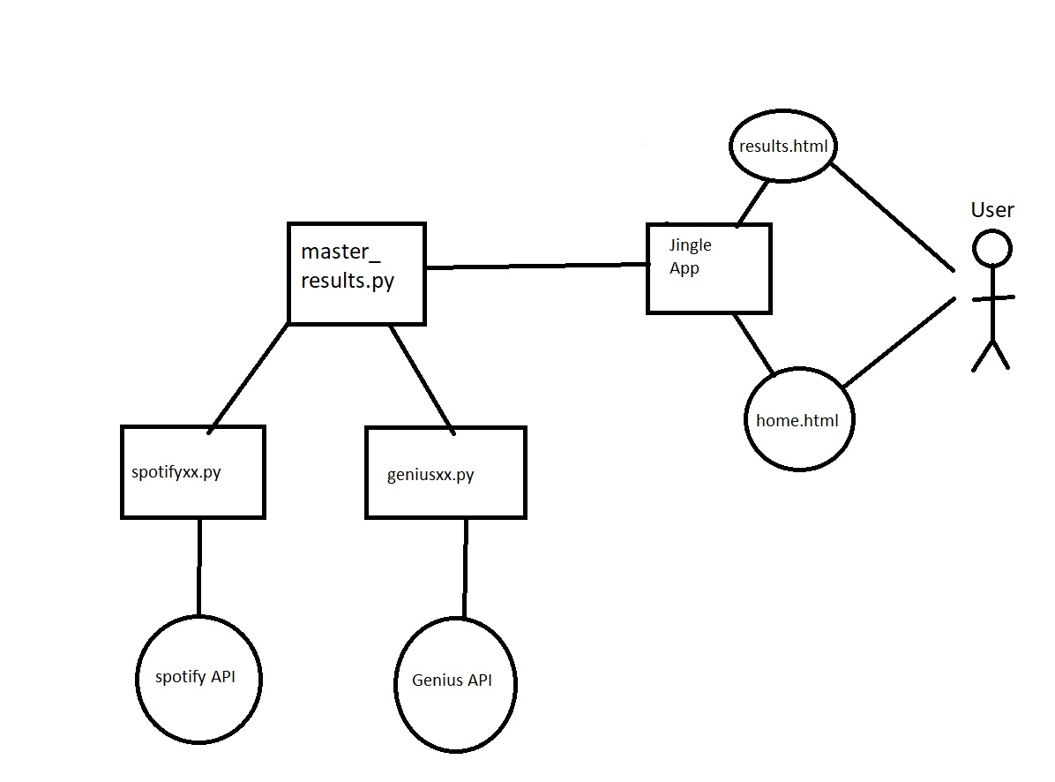

# Class Diagram and/or Sequence Diagrams (15 points)

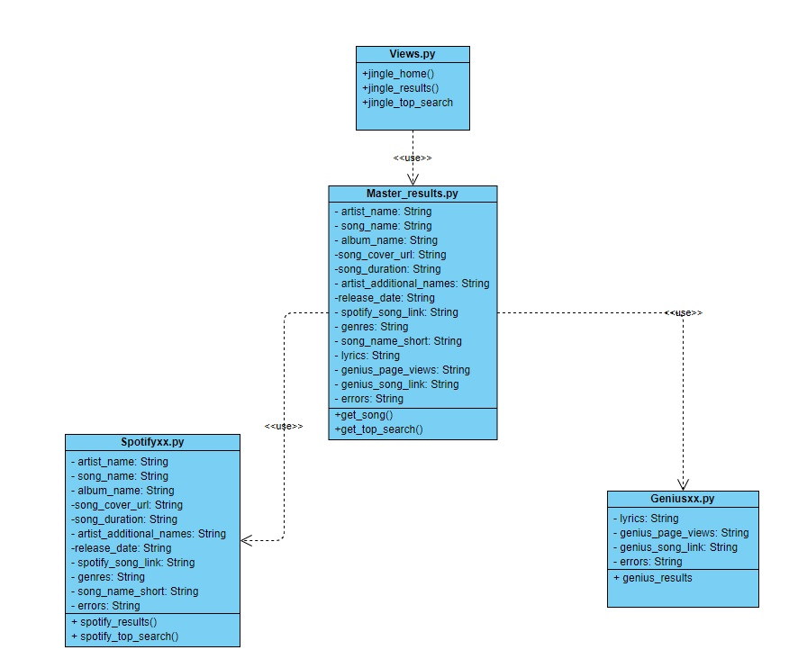

# Operating Environment (5 points)

The app will be running on a web server using the Django Framework. It is currently using Django version 3.0.4. It is also written in Python using Python 3. It also uses the Spotipy python library and the Beautiful Soup 4.0 Library. The final product is planned to be hosted by a web hosting company. It is also being tested primarily on Mac computers being ran through the terminal.

# Assumptions and Dependencies (5 points)

Some aspects of the code are dependent on the Spotify and Beautiful Soup python libraries. If any of these were to be shut down or stop working, parts of the code would be affected*.* The whole application is running on the Django framework, so all aspects and libraries of the framework must be functional. The server is also mainly ran on Mac for testing, but windows uses slightly different versions of some of the software that could cause issues while testing by individual group members.